Shrink Quest Game Design Document

United Scum

Shrink Quest Game Design Document

Danial Azimi

Deltion College

Gam20 & Gam21

# Contents

Contents 2

1. Team Goal 3

2. General Game Overview 3

2.1. Project Name 3

2.2. Genre 3

2.3. Narrative Setting 3

2.4. Game World 3

2.5. Game Character & Visualisation 3

2.6. Game Objective 3

2.7. Gameplay 4

3. Narrative 4

4. Game World 4

4.1. Level Structure 4

4.2. Look & Feel 4

4.3. Visual Representation & Function 4

4.4. Level Interaction 5

4.4.1. Pick ups 5

4.5. Abilities 5

4.5.1. Ability costs 5

4.6. NPC 6

4.7. Sounds 6

4.8. Menu Flow 7

4.9. Game Flow 7

4.10. HUD 8

# Team Goal

United Scum has set the goal to create a light hearted enjoyable game, with a scope that matches the given deadline of two school blocks. As a team we would like to broaden our knowledge of the complications that come paired with game development and increase our proficiency with game development tools.

# General Game Overview

In this section of the GDD you will find a brief description for the building blocks of Shrink Quest.

## Project Name

Shrink Quest

## Genre

Shrink Quest is a single player 3rd Person Action Adventure game influenced by Super Mario 64, Banjo and Kazooie and Prince of Persia.

## Narrative Setting

The main character has been shrunk by a freak experimental accident run by her father. The shed where the father holds his experiment has exploded caused by the accident, hurling the main character to the other side of the garden. Finding her way back will prove to safety be difficult now that the main character has being shrunk down to only a couple of millimetres, armed only with her wooden toy sword, imagination and a strange bracelet made by her father.

## Game World

The difference in the scale between the world and the main character is gigantic as she has been shrunk down in size. The size of everyday objects feels like same as that of big houses or storage containers.

## Game Character & Visualisation

The player is only able to control the main character in a third person perspective. The reasoning behind this design choice is that player needs a complete overview of their surrounding while navigating the game or being engaged in combat.

## Game Objective

The objective for the player is to navigate through the three levels and to return to normal. Along the way the player will find collectables. These collectables are not mandatory to finish the game as the player will get different endings depending on how many collectables they have collected.

## Gameplay

The fun factor of Shrink Quest emerges from several gameplay elements; platforming and navigation, combat and environmental aspects.

# Narrative

The Narrative during “cut scene phases” are visualised in a comic book fashion by the use of still images. In the event that dialogue is necessary dialogue will be shown on the bottom side of the screen. A cut scene phase can include; when starting the game, at the beginning or end of a level, tutorials when picking up a new power up, etc.

# Game World

Shrink Quest will feature three different major areas, each respective area being a level in the game. These areas are: the garden, the ant colony and the playroom. Level advancement is done in a linear order, the player is not able to skip a level or return to a previous one as this game will not feature a game hub.

## Level Structure

Every level has a small subdivision in areas focused on a gameplay aspect and each of these areas should flow into one and other. For instance an area with a platforming element will lead a path to an area that is focussed on a combat oriented space; this is to ensure that gameplay is diverse and does not turn stale.

Functionality is a key element to design of each area; the player should have a reason to traverse to certain locations; this will ensure that the player’s curiosity is stimulated so they will not lose interest in the game. Each area should have an appropriate scale in area functionality compared to size of the area; areas with a correct scale will not be perceived to feel empty or useless by the player.

## Look & Feel

The game features a surrealistic art style with a cartoonish feel. It instils a feeling of hostility through the design of the enemies and big sized objects and yet conveys a feeling of playfulness at the same time.

## Visual Representation & Function

The three levels have their own original assets that represent the theme of the level. Each level has a theme and bespoke assets. The garden contains objects that can be found in everyday life. The ant colony is based on a subterranean cave system that contain elements that can be found in caves. The playroom resembles a children’s playroom with certain locations that share the same theme as one of the abilities. The assests do not only serve a visual function but could also function as gameplay elements or as an environmental storytelling element. A list of assets that have gameplay elements are found in the table below.

## Level Interaction

### Level 1

|  |  |  |
| --- | --- | --- |
| Asset | Environmental storytelling | Gameplay element |
| Broken chemical veil. | A consequence of the exploded shed. | Creates puddles that are poisonous to the player. |
| Small Logs. | Random rubble in the garden. | Obstacles which can be climbed. |
| Quicksand. | Hazards in the sandbox. | Creates an area which the player should avoid. |
| Wooden Planks. | Leftovers from the exploded shed. | Creates safe spots in the chemical puddle. |
| Potted Plant | Decoration placed by mom & dad. | Creates a jumping platform area where the player can scale the balcony. |
| Coke Bottle | A spilled beverage, likely knocked over during the accident. | Creates a sticky puddle which slows player movement. |
| Lilypads | Growth in the pond. | Provides a way to cross the pond. |

### Level 2

|  |  |  |
| --- | --- | --- |
| Asset | Environmental storytelling | Gameplay element |
| Hollow treeroots. | Roots from the tree leading deeper underground. | Provides a slip and slide on which the player enters the level. |
| Falling rocks. | Hints that the caves through which the player progresses is unstable. | Creates a falling hazard, damaging the player upon contact. |
| Stalactites/stalagmites. | Natural formations caused by groundwater. | Blocks the player from progressing until destroyed. |
| Rocks/rubble. | Consequence from the unstable cave system. | Rocks which can be destroyed to create new pathways. |
| Pits. | Natural deformation in the caves. | Creates a hole in the ground which the player will have to jump over. |

### Level 3

|  |  |  |
| --- | --- | --- |
| Asset | Environmental storytelling | Gameplay element |
| Teleporter. | A crazy invention by your father, how is he not a world famous scientist?!! | Teleports you for progress. |
| Jack in a box. | A toy box with a surprise inside. | Throws you off a platform for increased difficulty. |
| Bed | Where your little brother sleeps. | Creates a bouncy surface. |

## Pick ups

The player is able to gather a pick up; this pick up is represented by a piece of technology (microchip, circuit board). There are 150 pickups in total the player can gather throughout the game, 50 pickups can be found per level. These pickups are put in the levels to help the player navigate or lure them into certain parts of the game. The player is able to get different endings dependent on the amount of pickups gathered.

## Abilities

The player has several abilities that they can unlock throughout the game; these are the knight, cowboy, astronaut and superhero abilities and are unlocked by picking them up from the environment.

* Normal

All-rounder, base movement speed and attacks with a sword.

* Knight

The knight is able to block incoming attacks. Player movement is slowed and attacks with a slightly longer sword.

* Cowboy

Movement speed is the same as normal; the sword is replaced by revolvers that can shoot. Special ability is throwing dynamite.

* Astronaut

Gravity is lowered; normal walk cycle is replaced by moon hopping. The player is able to double jump, attacks are performed with a saber.

* Superhero

Movement speed is the same as normal; Attacks with her fists, is able to glide for a short distance after a jump.

As soon as the player activates an ability the player avatar will change accordingly, this means that the player avatar will get bespoke 3D models in the form of accessories that represent the respective ability. This transformation is accompanied by the necessary particle effects.

## Ability costs

An activated ability will drain the player from mana preventing the player from abusing their power and limits them to the bounds of the game world. Depleted mana will replenish itself on a slow and steady pace, or can be filled quicker by collecting “mana orbs” from enemies.

## NPC

The npc’s in this game are mainly enemies; these enemies are clustered in specified combat locations. Their main behaviours are patrolling in their area or following and attacking the player when in range.

## Sounds

The sound effects are mainly oriented around giving the player feedback about what is action is being triggered, whether it is triggered by the player itself or by the game. These sounds include:

Player hits monster

Monster hits player

Level hits player

Death sound

Agro sound effect

Collectable pick up

Combat area cleared

Cowboy transformation

Knight transformation

Astronaut transformation

Super hero transformation

Normal transformation

Sword swing

Light saber swing

Gliding sound

Punch sound

Revolver sound

## 

## Menu Flow

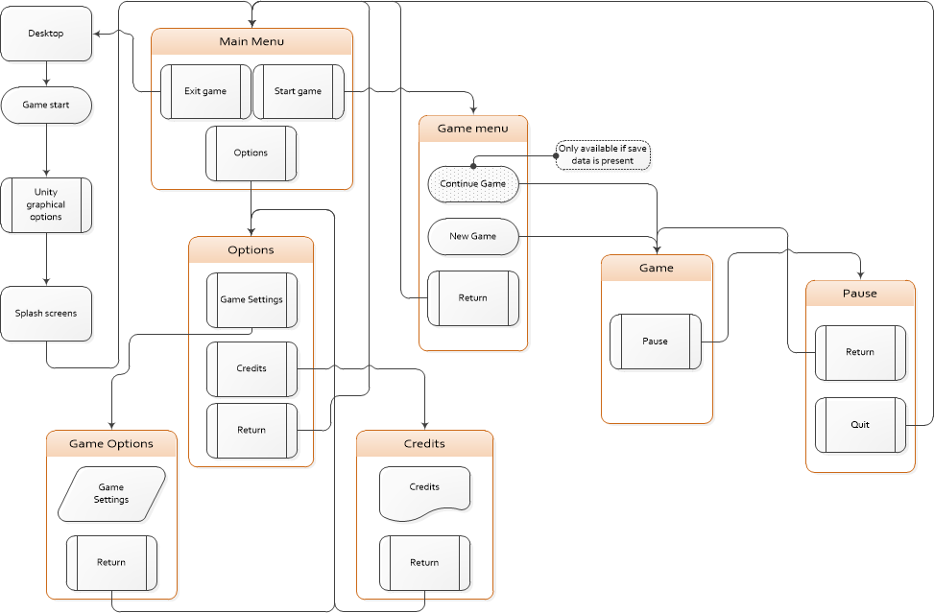

## Game Flow

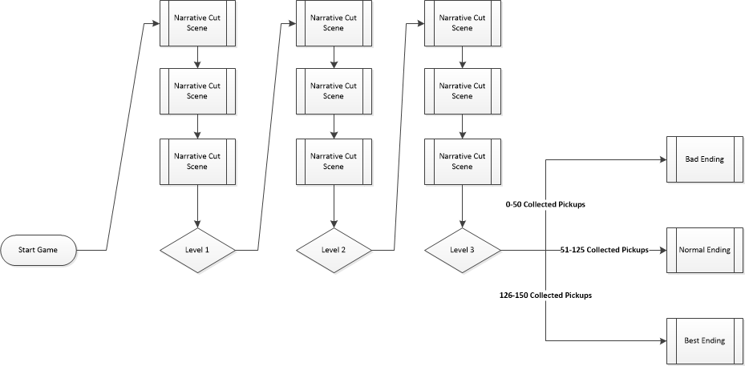

## HUD

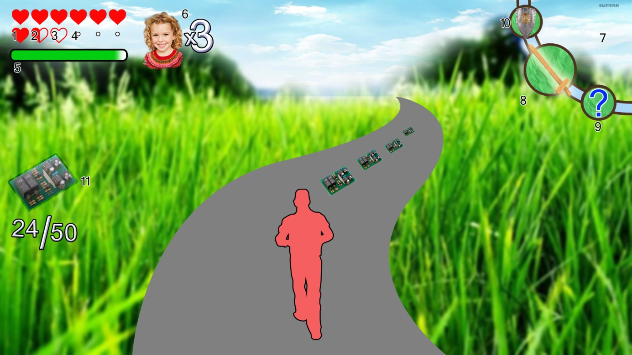

1. **Full heart**

Heart container with full health

1. **Half heart**

Heart container with half health

1. **Empty heart**

Empty heart container

1. **Unlocked heart container**

Designation for an unlockable heart container

1. **Mana bar**

Container for amount of unused mana

1. **Player lives**

Amount of lives

1. **Skill Carousel**

HUD element that displays the currently active, previous selected and following skill.

1. **Active skill**

Highlights the currently active skill

1. **locked skill**

A skill that has not been unlocked is signified by a question mark in the carousel.

1. **Inactive skill**

Shows a skill that came before or comes after the current selected skill

1. **Collectable Counter**

This HUD element is activated when the player gathers a pickup. It will show the player the amount of collectables gathered for that level

## Controls

This game will support controls for keyboard + mouse and the xbox controller. The character moves through the wasd keys and left control stick, the camera is controlled with the mouse or right control stick. Jumping is triggered by pressing the spacebar. The button prompts are showed during the splash screens. Individual text based tutorials with images for abilities are showed when a skill is picked up for the first time.